A suite of computer vision deep learning algorithms

We provide here a suite of deep learning computer vision algorithms that are ready for real-world use:

**\***[**Similar image finder (using transfer learning)**](https://github.com/ankonzoid/artificio/tree/master/similar_images_TL)

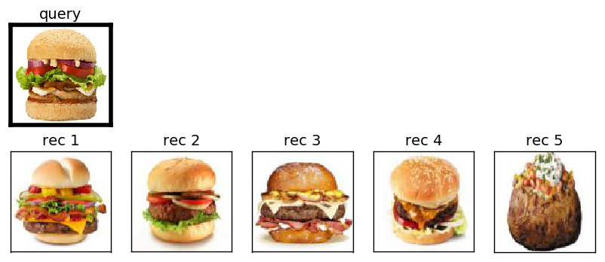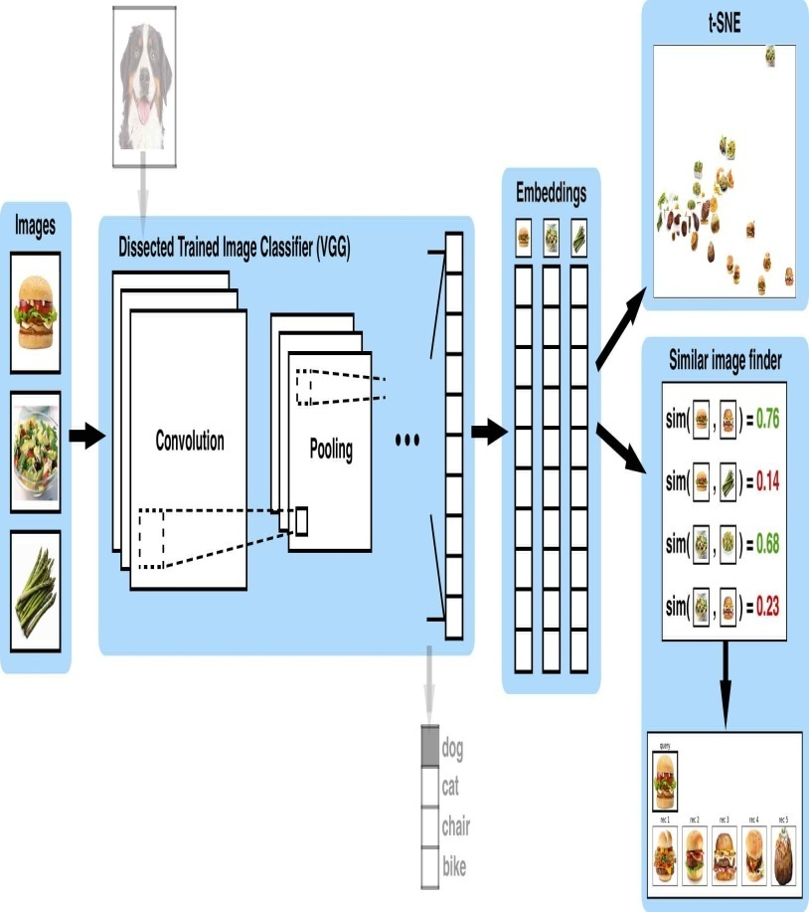

**\***[**Similar image finder (using autoencoders)**](https://github.com/ankonzoid/artificio/tree/master/similar_images_AE)

